I. INTRODUCTION
Development of electrical power supplies began more than one hundred years ago. This is because the development of electrical power sector historically links to the economic advancement of country. The traditional way to develop the transmission network in order to achieve better linkage between generation and demand was to reinforce the grid, mainly by installing new lines and substations. However, in recent years substantial changes were implemented in the traditional structures of electric power systems throughout the world. The general reason for this is to improve efficiency. Interconnected power networks operate in different parts and locations or countries that may require different power demand during a certain period of time. These requirements limit the flexibility of the interconnected power network in technical and economical terms. Therefore, establishing a desired power condition at the given points in the above are best achieved using power controllers such as the well known HVDC and FACTS devices. FACTS and HVDC development over the past two decades are benefited from dramatic advances in power semiconductor technology. As a result of very substantial investments and continued R&D efforts, several manufacturers have been able to supply FACTS and HVDC systems for all practical needs of the industry. Conventional stability analysis of ac systems incorporating HVDC links or FACTs devices use either steady state or quasi-steady state representations of these non-linear components. While these programs are entirely adequate for representing the dynamic behavior of generators, they are compromised by their limited representation of non-linear components.
Since the development of interconnection of large electric power systems, there have been spontaneous oscillations at very low frequencies in order of 0.2–3.0 Hz. Once started, they would continue for a long period of time. In some cases, they continue to grow causing system separation due to the lack of damping of the mechanical modes. In the past three decades, power system stabilizers (PSSs) have been extensively used to increase the system damping for low frequency oscillations. The power utilities worldwide are currently implementing PSSs as effective excitation controllers to enhance the system stability. However, there have been problems experienced with PSSs over the years of operation. Some of these were due to the limited capability of PSS, in damping only local and not inter area modes of oscillations. In addition, PSSs can cause great variations in the voltage profile under severe disturbances and they may even result in leading power factor operation and losing system stability. This situation has necessitated a review of the traditional power system concepts and practices to achieve a larger stability margin, greater operating flexibility, and better utilization of existing power systems. Flexible AC transmission systems (FACTS) have gained a great interest during the last few years, due to recent advances in power electronics. FACTS devices have been mainly used for solving various power system steady state control problems such as voltage regulation, power flow control, and transfer capability enhancement. As supplementary functions, damping the inter area modes and enhancing power system stability using FACTS controllers have been extensively studied and investigated. Generally, it is not cost-effective to install FACTS devices for the sole purpose of power system stability enhancement. In this work, the current status of power system stability enhancement using FACTS controllers was discussed and reviewed.
We need the interconnections because, apart from delivery, the purpose of the transmission network is to pool power plants and load centers in order to minimize the total power generation capacity and fuel cost. Transmission interconnections enable taking advantage of diversity of loads, availability of sources, and fuel price in order to supply electricity to the loads at minimum cost with a required reliability. In general, if a power delivery system was made up of radial lines from individual local generators without being part of a grid system, many more generation resources would be needed to serve the load with the same reliability, and the cost of electricity would be much higher. With that perspective, transmission is often an alternative to a new generation resource. Less transmission capability means that more generation resources would be required regardless of whether the system is made up of large or small power plants. In fact small distributed generation becomes more economically viable if there is a backbone of a transmission grid. One cannot be really sure about what the optimum balance is between generation and transmission unless the system planners use advanced methods of analysis which integrate transmission planning into an integrated value-based transmission/generation planning scenario. The cost of transmission lines and losses, as well as difficulties encountered in building new transmission lines, would often limit the available transmission capacity. It seems that there are many cases where economic energy or reserve sharing is constrained by transmission capacity, and the situation is not getting any better. In a deregulated electric service environment, an effective electric grid is vital to the competitive environment of reliable electric service.
On the other hand, as power transfers grow, the power system becomes increasingly
more complex to operate and the system can become less secure for riding through the major outages. It may lead to large power flows with inadequate control, excessive reactive power in various parts of the system, large dynamic swings between different parts of the system and bottlenecks, and thus the full potential of transmission interconnections cannot be utilized.The power systems of today, by and large, are mechanically controlled. There is a widespread use of microelectronics, computers and high-speed communications for control and protection of present transmission systems; however, when operating signals are sent to the power circuits, where the final power control action is taken, the switching devices are mechanical and there is little high-speed control. Another problem with mechanical devices is that control cannot be initiated frequently, because these mechanical devices tend to wear out very quickly compared to static devices. In effect, from the point of view of both dynamic and steady-state operation, the system is really uncontrolled. Power system planners, operators, and engineers have learned to live with this limitation by using a variety of ingenious techniques to make the system work effectively, but at a price of providing greater operating margins and redundancies. These represent an asset that can be effectively utilized with prudent use of FACTS technology on a selective, as needed basis. In recent years, greater demands have been placed on the transmission network and these demands
will continue to increase because of the increasing number of nonutility generators and heightened competition among utilities themselves. Added to this is the problem that it is very difficult to acquire new rights of way. Increased demands on transmission, absence of long-term planning, and the need to provide open access to generating companies and customers, all together have created tendencies toward less security and reduced quality of supply. The FACTS technology is essential to alleviate some but not all of these difficulties by enabling utilities to get the most service from their transmission facilities and enhance grid reliability. It must be stressed, however, that for many of the capacity expansion needs, building of newlines or upgrading current and voltage capability of existing lines and corridors will be necessary.
Interconnection of power systems with either AC or DC links may offer important technical, economical and environmental advantages. In the future of liberalized power markets, these advantages will become even more important, pooling of large power stations, as well as ecological constraints nuclear power stations at selected locations, hydro energy from remote areas, solar energy from steppes and deserts, and connection of large off-shore wind farms.. However, interconnections by AC and increasingly by DC are in progress in Far East, too. Since the 60s, FACTS (Flexible AC Transmission Systems) and HVDC (High Voltage Direct Current) transmission have developed into a mature technology with high power ratings. Transmission ratings of 3 GW over large distances with just one bipolar DC transmission system are state of the art in many grids today. Reason for such high ratings is the need for bulk power transmission corridors with 20 GW for system interconnection. In general, for transmission distances above 700 km, DC transmission is more economical than AC transmission (≥ 1000 MW). With submarine cables, transmission levels of up to 600 - 800 MW over distances of nearly 300 km have already been attained, and cable transmission lengths of up to 1,300 km are in the planning stage. As a multi-terminal system, HVDC can also be connected at several points with the surrounding AC networks. FACTS is applicable in parallel connection (SVC, Static VAR Compensator – STATCOM, Static Synchronous Compensator) or in series connection (FSC, Fixed Series Compensation - TCSC, Thruster Controlled Series Compensation – TPSC, Thruster Protected Series Compensation) or in combination of both (UPFC, Unified Power Flow Controller) to control load flow and to improve dynamic conditions.
II. CONCEPTS OF POWER QUALITY
2.1: Introduction to power quality:
Power quality is the set of limits of electrical properties that allows electrical systems to function in their intended manner without significant loss of performance or life. The term is used to describe electric power that drives an electrical load and the load's ability to function properly with that electric power. Without the proper power, an electrical device (or load) may malfunction, fail prematurely or not operate at all. There are many ways in which electric power can be of poor quality and many more causes of such poor quality power.
The electric power industry comprises electricity generation (AC power), electric power transmission and ultimately electricity distribution to an electricity meter located at the premises of the end user of the electric power. The electricity then moves through the wiring system of the end user until it reaches the load. The complexity of the system to move electric energy from the point of production to the point of consumption combined with variations in weather, generation, demand and other factors provide many opportunities for the quality of supply to be compromised.
While "power quality" is a convenient term for many, it is the quality of the voltage—rather than power or electric current—that is actually described by the term. Power is simply the flow of energy and the current demanded by a load is largely uncontrollable.
2.2: Power quality issues:
The PQ problems are categorized as follows
1. Transients
(a) Impulsive
(b) Oscillatory
2. Short-duration and Long-duration variations
(a) Interruptions
(b) Sag (dip)
(c) Swell
3. Voltage unbalance
4. Waveform distortion
(a) DC offset
(b) Harmonics
(c) Interharmonics
(d) Notching
(e) Noise
5. Voltage Flicker
6. Power frequency variations.
Transient problems:
Transients are very short duration (sub-cycle) events of varying amplitude. Often referred to as "surges", transients are probably most frequently visualized as the tens of thousands of volts from a lighting strike that destroys any electrical device in its path.
Transients can be caused by equipment operation or failure or by weather phenomena like lightning. Even relatively low voltage transients can cause damage to electrical components if the occur with any frequency.
A properly sized industrial-grade surge suppressor is usually ample protection from the damaging effects of high voltage transients.
Sag:
The American "sag" and the British "dip" are both names for a decrease in voltage to between 10 and 90% of nominal voltage for one-half cycle to one minute Sags account for the vast majority of power problems experienced by end users. They can be generated both internally and externally from an end users facility.
External causes of sags primarily come from the utility transmission and distribution network. Sags coming from the utility have a variety of cause including lightning, animal and human activity, and normal and abnormal utility equipment operation. Sags generated on the transmission or distribution system can travel hundreds of miles thereby affecting thousands of customers during a single event. Sometimes externally caused sags can be generated by other customers nearby.
The starting of large electrical loads or switching off shunt capacitor banks can generate sag large enough to affect a local area. If the end user is already subject to chronic under voltage, then even a relatively small amplitude sag can have detrimental effects. Sags caused internally to an end user's facility are typically generated by the starting of large electrical loads such as motors or magnets. The large inrush of current required to starts these types of loads depresses the voltage level available to other equipment that share the same electrical system. As with externally caused sags, ones generated internally will be magnified by chronic under voltage.
Swell:
A swell is the opposite of sag - an increase in voltage above 110% of nominal for one-half cycle to one minute. Although swells occur infrequently when compared to sags, they can cause equipment malfunction and premature wear. Swells can be caused by shutting off loads or switching capacitor banks on.

Noise:
Noise is a high frequency distortion of the voltage waveform. Caused by disturbances on the utility system or by equipment such as welders, switchgear and transmitters, noise can frequently go unnoticed. Frequent or high levels of noise can cause equipment malfunction, overheating and premature wear.
Notching:
Notching is a disturbance of opposite polarity to the normal voltage waveform (which is subtracted from the normal waveform) lasting for less than one-half cycle. Notching is frequently caused by malfunctioning electronic switches or power conditioners. While it is generally not a major problem, notching can cause equipment, especially electronics, to operate improperly.
Harmonics:
Harmonics are a recurring distortion of the waveform that can be caused by various devices including variable frequency drives, non-linear power supplies and electronic ballasts. Certain types of power conditioners like ferroresonant or constant voltage (CVT) transformers can add significant harmonic distortion to the waveform. Waveform distortion can also be an issue with uninterruptible power supplies (UPS) and other inverter-based power conditioners. The UPS does not actually add distortion, but because the UPS digitally synthesizes a waveform, that waveform may be square or jagged rather than a smooth sine wave. Symptoms of harmonic distortion include overheating and equipment operational problems.

III. INTRODUCTION TO FACTS
Flexible AC Transmission Systems, called FACTS, got in the recent years a well known term for higher controllability in power systems by means of power electronic devices. Several FACTS-devices have been introduced for various applications worldwide. A number of new types of devices are in the stage of being introduced in practice.
In most of the applications the controllability is used to avoid cost intensive or landscape requiring extensions of power systems, for instance like upgrades or additions of substations and power lines. FACTS-devices provide a better adaptation to varying operational conditions and improve the usage of existing installations. The basic applications of FACTS-devices are:
- Power flow control
- Increase of transmission capability
- Voltage control
- Reactive power compensation
- Stability improvement
- Power quality improvement
- Power conditioning
- Flicker mitigation
- Interconnection of renewable and distributed generation and storages
Figure shows the basic idea of FACTS for transmission systems. The usage of lines for active power transmission should be ideally up to the thermal limits. Voltage and stability limits shall be shifted with the means of the several different FACTS devices. It can be seen that with growing line length, the opportunity for FACTS devices gets more and more important.
The influence of FACTS-devices is achieved through switched or controlled shunt compensation, series compensation or phase shift control. The devices work electrically as fast current, voltage or impedance controllers. The power electronic allows very short reaction times down to far below one second.
The development of FACTS-devices has started with the growing capabilities of power electronic components. Devices for high power levels have been made available in converters for high and even highest voltage levels. The overall starting points are network elements influencing the reactive power or the impedance of a part of the power system. Figure 3.1 shows a number of basic devices separated into the conventional ones and the FACTS-devices.
For the FACTS side the taxonomy in terms of 'dynamic' and 'static' needs some explanation. The term 'dynamic' is used to express the fast controllability of FACTS-devices provided by the power electronics. This is one of the main differentiation factors from the conventional devices.
The term 'static' means that the devices have no moving parts like mechanical switches to perform the dynamic controllability. Therefore most of the FACTS-devices can equally be static and dynamic.

3.1 Types of FACTS devices:
.
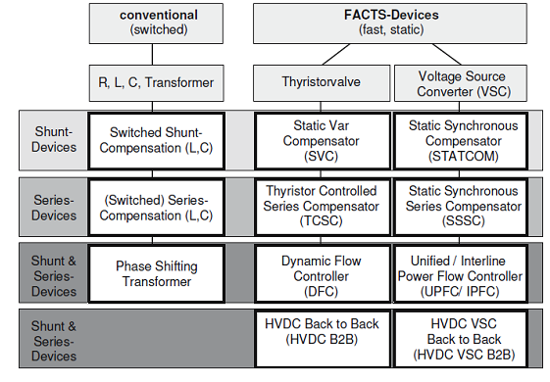
Fig 3.1: types of FACTS devices
The left column in Figure 3.1 contains the conventional devices build out of fixed or mechanically switch able components like resistance, inductance or capacitance together with transformers. The FACTS-devices contain these elements as well but use additional power electronic valves or converters to switch the elements in smaller steps or with switching patterns within a cycle of the alternating current. The left column of FACTS-devices uses Thyristor valves or converters. These valves or converters are well known since several years. They have low losses because of their low switching frequency of once a cycle in the converters or the usage of the Thyristors to simply bridge impedances in the valves.
The right column of FACTS-devices contains more advanced technology of voltage source converters based today mainly on Insulated Gate Bipolar Transistors (IGBT) or Insulated Gate Commutated Thyristors (IGCT). Voltage Source Converters provide a free controllable voltage in magnitude and phase due to a pulse width modulation of the IGBTs or IGCTs. High modulation frequencies allow to get low harmonics in the output signal and even to compensate disturbances coming from the network. The disadvantage is that with an increasing switching frequency, the losses are increasing as well. Therefore special designs of the converters are required to compensate this.
3.2 Shunt devices:
The most used FACTS-device is the SVC or the version with Voltage Source Converter called STATCOM. These shunt devices are operating as reactive power compensators. The main applications in transmission, distribution and industrial networks are:
- Reduction of unwanted reactive power flows and therefore reduced network losses.
- Keeping of contractual power exchanges with balanced reactive power.
- Compensation of consumers and improvement of power quality especially with huge demand fluctuations like industrial machines, metal melting plants, railway or underground train systems.
- Compensation of Thyristor converters e.g. in conventional HVDC lines.
- Improvement of static or transient stability.
Almost half of the SVC and more than half of the STATCOMs are used for industrial applications. Industry as well as commercial and domestic groups of users require power quality. Flickering lamps are no longer accepted, nor are interruptions of industrial processes due to insufficient power quality. Railway or underground systems with huge load variations require SVCs or STATCOMs.
SVC
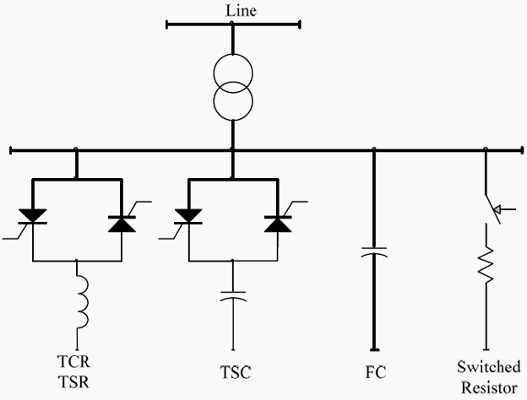
Fig 3.2: basic circuit for SVC
Electrical loads both generate and absorb reactive power. Since the transmitted load varies considerably from one hour to another, the reactive power balance in a grid varies as well. The result can be unacceptable voltage amplitude variations or even a voltage depression, at the extreme a voltage collapse.
A rapidly operating Static Var Compensator (SVC) can continuously provide the reactive power required to control dynamic voltage oscillations under various system conditions and thereby improve the power system transmission and distribution stability.

3.2.1 Applications of the svc systems in transmission systems:
- To increase active power transfer capacity and transient stability margin
- To damp power oscillations
- To achieve effective voltage control
In addition, SVCs are also used
1. In Transmission Systems
a. To reduce temporary over voltages
b. To damp sub synchronous resonances
c. To damp power oscillations in interconnected power systems
2. In Traction Systems
a. To balance loads
b. To improve power factor
c. To improve voltage regulation
3. In HVDC systems
a. To provide reactive power to ac–dc converters
4. In arc furnaces
a. To reduce voltage variations and associated light flicker
Installing an SVC at one or more suitable points in the network can increase transfer capability and reduce losses while maintaining a smooth voltage profile under different network conditions. In addition an SVC can mitigate active power oscillations through voltage amplitude modulation.
SVC installations consist of a number of building blocks. The most important is the Thyristor valve, i.e. stack assemblies of series connected anti-parallel Thyristors to provide controllability. Air core reactors and high voltage AC capacitors are the reactive power elements used together with the Thyristor valves. The step up connection of this equipment to the transmission voltage is achieved through a power transformer.

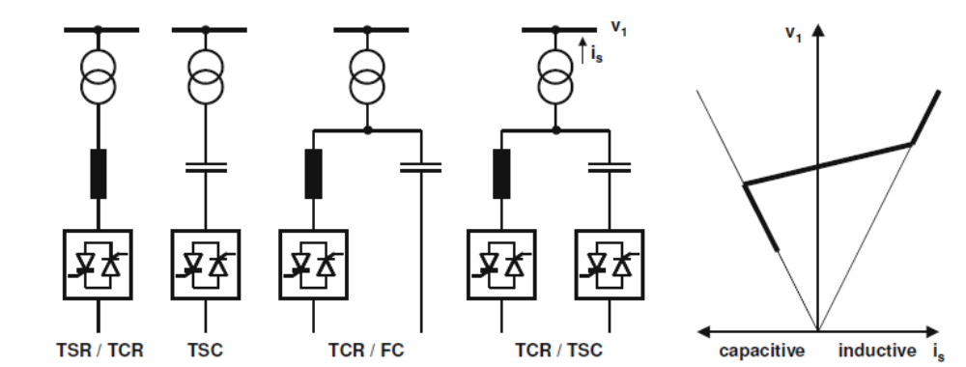
Fig 3.3: circuit of SVC
3.2.2 Thyristor-Switched Series Capacitor (TSSC):
The basic circuit arrangement of the thyristor-switched series capacitor. It consists of a number of capacitors, each shunted by an appropriately rated by pass valve composed of a string of reverse parallel connected thyristors, in series. As seen, it is similar to the circuit structure of the sequentially operated GCSC 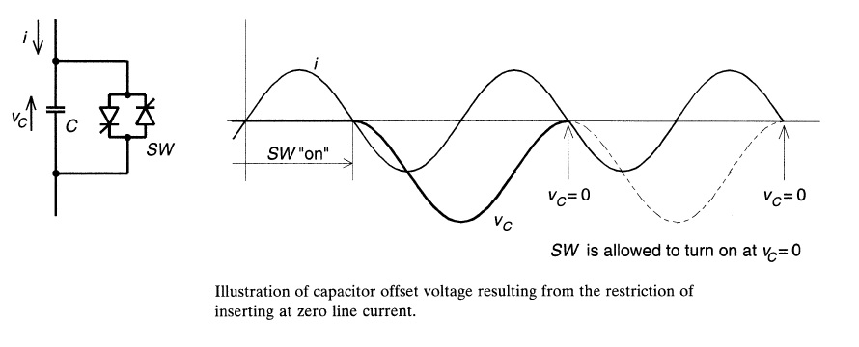
Fig 3.4: circuit for TSSC
but its operation is different due to the imposed switching restrictions of the conventional thyristor valve. The operating principle of the TSSC is straightforward: the degree of series compensation is controlled in a step-like manner by increasing or decreasing the number of series capacitors inserted. A capacitor is inserted by turning off, and it is bypassed by turning on the corresponding thyristor valve. A thyristor valve commutates "naturally," that is, it turns off when the current crosses zero. Thus a capacitor can be inserted into the line by the thyristor valve only at the zero crossings of the line current.
In order to minimize the initial surge current in the valve, and the corresponding circuit transient, the thyristor valve should be turned on for bypass only when the capacitor voltage is zero. With the prevailing dc offset, this requirement can cause a delay of up to one full cycle, which would set the theoretical limit for the attainable response time of the TSSC. The TSSC can control the degree of series compensation by either inserting or bypassing series capacitors but it cannot change the natural characteristic of the classical series capacitor compensated line. This means that a sufficiently high degree of TSSC compensation could cause sub synchronous resonance just as well as an ordinary capacitor. In principle, the TSSC switching could be modulated to counteract sub synchronous oscillations. However, considering the relatively long switching delays en- countered, the modulation is likely to be ineffective, if not counterproductive, except for the very low end of the sub synchronous frequency band.
The basic V-I characteristic of the TSSC with four series connected compensator modules operated to control the compensating voltage is shown in Fig.

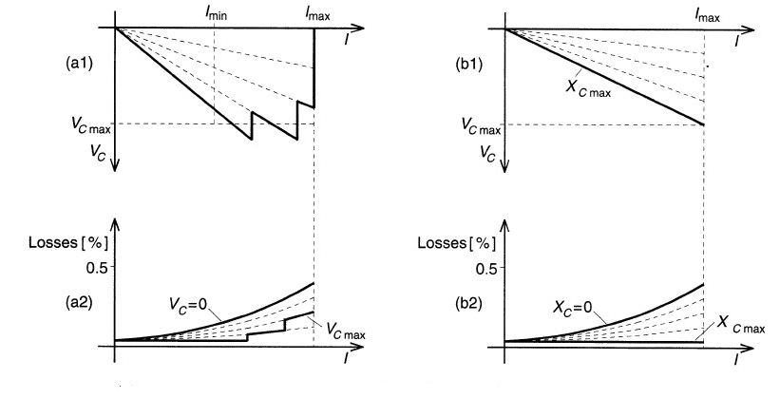
Fig 3.5: V-I characteristics of TSSC

3.2.3 SVC building blocks and voltage / current characteristic:
In principle the SVC consists of Thyristor Switched Capacitors (TSC) and Thyristor Switched or Controlled Reactors (TSR / TCR). The coordinated control of a combination of these branches varies the reactive power as shown in Figure. The first commercial SVC was installed in 1972 for an electric arc furnace. On transmission level the first SVC was used in 1979. Since then it is widely used and the most accepted FACTS-device.
3.2.4 SVC using a TCR and an FC:
In this arrangement, two or more FC (fixed capacitor) banks are connected to a TCR (thyristor controlled reactor) through a step-down transformer. The rating of the reactor is chosen larger than the rating of the capacitor by an amount to provide the maximum lagging vars that have to be absorbed from the system. By changing the firing angle of the thyristor controlling the reactor from 90° to 180°, the reactive power can be varied over the entire range from maximum lagging vars to leading vars that can be absorbed from the system by this compensator.

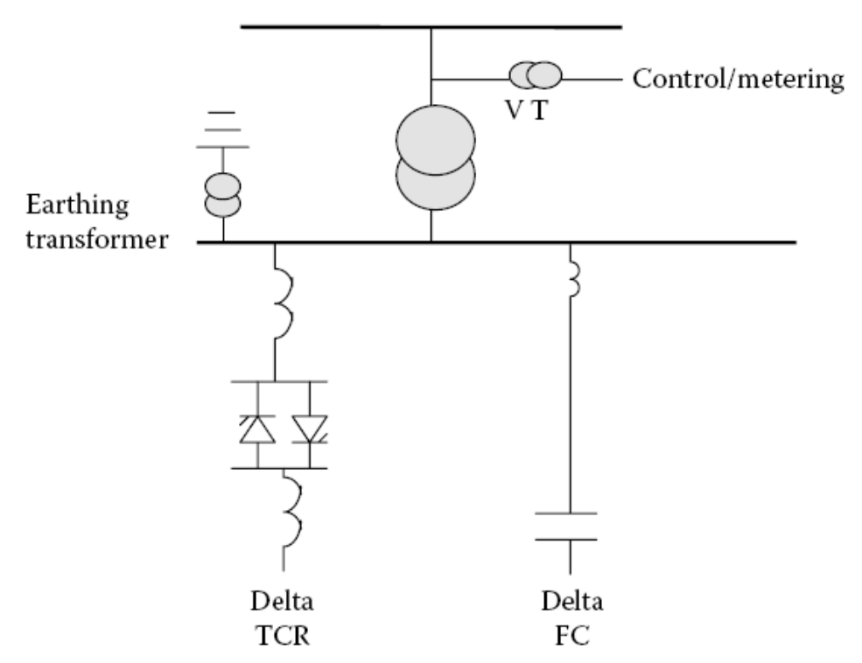
Fig 3.6: circuit for TCR and FC
3.2.5 SVC of the FC/TCR type:
The main disadvantage of this configuration is the significant harmonics that will be generated because of the partial conduction of the large reactor under normal sinusoidal steady-state operating condition when the SVC is absorbing zero MVAr. These harmonics are filtered in the following manner.
Triplex harmonics are canceled by arranging the TCR and the secondary windings of the step-down transformer in delta connection. The capacitor banks with the help of series reactors are tuned to filter fifth, seventh, and other higher-order harmonics as a high-pass filter. Further losses are high due to the circulating current between the reactor and capacitor banks.

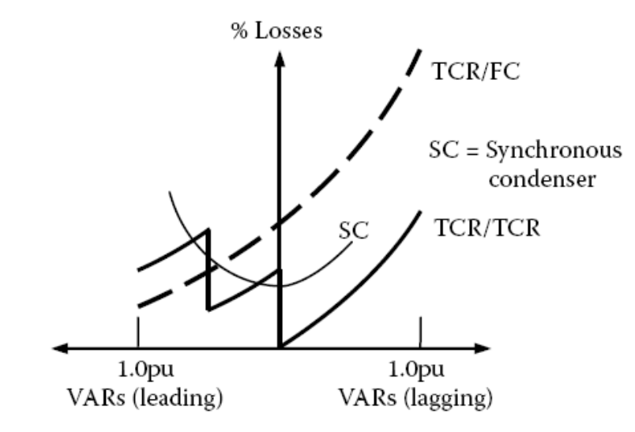
Fig 3.7: characteristics for FC/TCR
Comparison of the loss characteristics of TSC–TCR, TCR–FC compensators and synchronous condenser These SVCs do not have a short-time overload capability because the reactors are usually of the air-core type. In applications requiring overload capability, TCR must be designed for short-time overloading, or separate thyristor-switched overload reactors must be employed.
3.2.6 SVC using a TCR and TSC:
This compensator overcomes two major shortcomings of the earlier compensators by reducing losses under operating conditions and better performance under large system disturbances. In view of the smaller rating of each capacitor bank, the rating of the reactor bank will be 1/n times the maximum output of the SVC, thus reducing the harmonics generated by the reactor. In those situations where harmonics have to be reduced further, a small amount of FCs tuned as filters may be connected in parallel with the TCR.

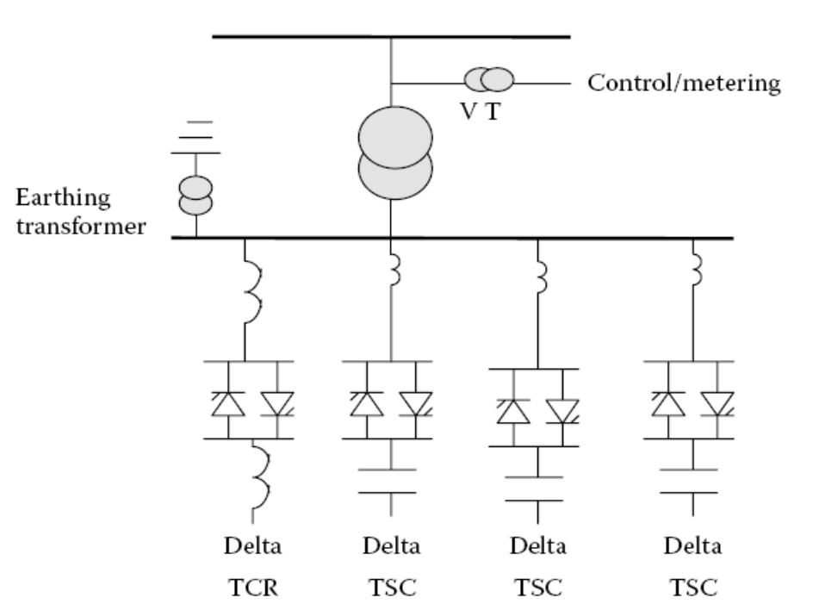
Fig 3.8: circuit for TCR and TSC
3.2.7 SVC of combined TSC and TCR type:
When large disturbances occur in a power system due to load rejection, there is a possibility for large voltage transients because of oscillatory interaction between system and the SVC capacitor bank or the parallel. The LC circuit of the SVC in the FC compensator. In the TSC–TCR scheme, due to the flexibility of rapid switching of capacitor banks without appreciable disturbance to the power system, oscillations can be avoided, and hence the transients in the system can also be avoided. The capital cost of this SVC is higher than that of the earlier one due to the increased number of capacitor switches and increased control complexity.
3.2.8 STATCOM:
In 1999 the first SVC with Voltage Source Converter called STATCOM (Static Compensator) went into operation. The STATCOM has a characteristic similar to the synchronous condenser, but as an electronic device it has no inertia and is superior to the synchronous condenser in several ways, such as better dynamics, a lower investment cost and lower operating and maintenance costs. A STATCOM is build with Thyristors with turn-off capability like GTO or today IGCT or with more and more IGBTs. The static line between the current limitations has a certain steepness determining the control characteristic for the voltage.
The advantage of a STATCOM is that the reactive power provision is independent from the actual voltage on the connection point. This can be seen in the diagram for the maximum currents being independent of the voltage in comparison to the SVC. This means, that even during most severe contingencies, the STATCOM keeps its full capability.
In the distributed energy sector the usage of Voltage Source Converters for grid interconnection is common practice today. The next step in STATCOM development is the combination with energy storages on the DC-side. The performance for power quality and balanced network operation can be improved much more with the combination of active and reactive power.
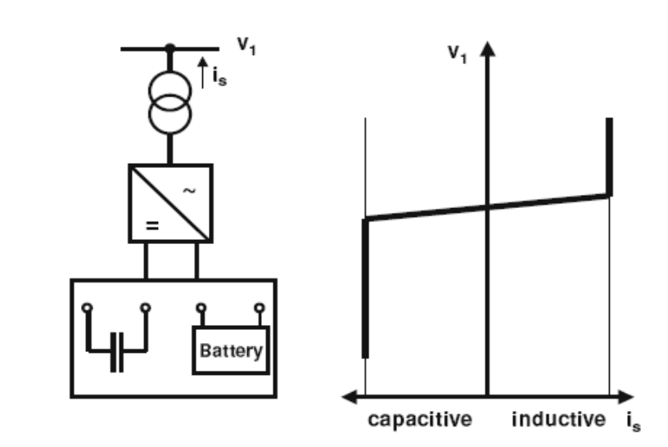
Fig 3.9: circuit for STATCOM

3.2.9 STATCOM structure and voltage / current characteristic:
STATCOMs are based on Voltage Sourced Converter (VSC) topology and utilize either Gate-Turn-off Thyristors (GTO) or Isolated Gate Bipolar Transistors (IGBT) devices. The STATCOM is a very fast acting, electronic equivalent of a synchronous condenser. If the STATCOM voltage, Vs, (which is proportional to the dc bus voltage Vc) is larger than bus voltage, Es, then leading or capacitive VARS are produced. If Vs is smaller then Es then lagging or inductive VARS are produced.
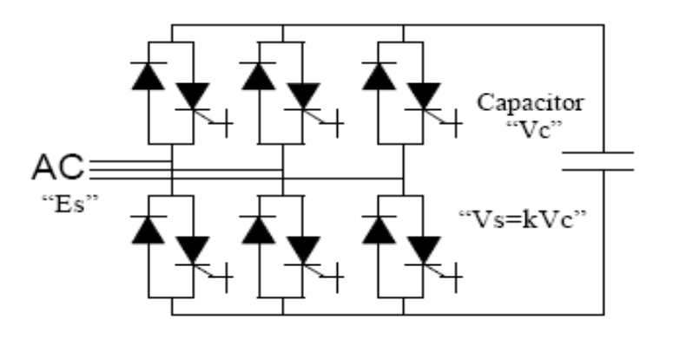
Fig 3.10: STATCOM voltage/current characteristics
3.3.10 6 pulses STATCOM:
The three phases STATCOM makes use of the fact that on a three phase, fundamental frequency, steady state basis, and the instantaneous power entering a purely reactive device must be zero. The reactive power in each phase is supplied by circulating the instantaneous real power between the phases. This is achieved by firing the GTO/diode switches in a manner that maintains the phase difference between the ac bus voltage ES and the STATCOM generated voltage VS. Ideally it is possible to construct a device based on circulating instantaneous power which has no energy storage device (ie no dc capacitor).
A practical STATCOM requires some amount of energy storage to accommodate harmonic power and ac system unbalances, when the instantaneous real power is non-zero. The maximum energy storage required for the STATCOM is much less than for a TCR/TSC type of SVC compensator of comparable rating.
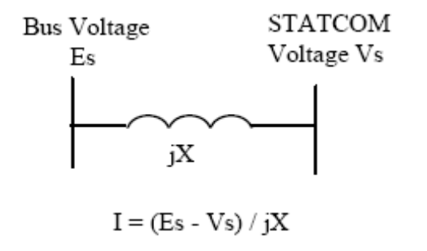
Fig 3.11:STATCOM equivalent circuit
Several different control techniques can be used for the firing control of the STATCOM.
Fundamental switching of the GTO/diode once per cycle can be used. This approach will minimize switching losses, but will generally utilize more complex transformer topologies. As an alternative, Pulse Width Modulated (PWM) techniques, which turn on and off the GTO or IGBT switch more than once per cycle, can be used. This approach allows for simpler transformer topologies at the expense of higher switching losses.
The 6 Pulse STATCOM using fundamental switching will of course produce the 6 N+1 harmonics. There are a variety of methods to decrease the harmonics. These methods include the basic 12 pulse configuration with parallel star / delta transformer connections, a complete elimination of 5th and 7th harmonic current using series connection of star/star and star/delta transformers and a quasi 12 pulse method with a single star-star transformer, and two secondary windings, using control of firing angle to produce a 30  phase shift between the two 6 pulse bridges.
This method can be extended to produce a 24 pulse and a 48 pulse STATCOM, thus eliminating harmonics even further. Another possible approach for harmonic cancellation is a multi-level configuration which allows for more than one switching element per level and therefore more than one switching in each bridge arm. The ac voltage derived has a staircase effect, dependent on the number of levels. This staircase voltage can be controlled to eliminate harmonics.
3.3 Series devices:
Series devices have been further developed from fixed or mechanically switched compensations to the Thyristor Controlled Series Compensation (TCSC) or even Voltage Source Converter based devices.
The main applications are:
- Reduction of series voltage decline in magnitude and angle over a power line,
• Reduction of voltage fluctuations within defined limits during changing power transmissions,
• Improvement of system damping resp. damping of oscillations,
• Limitation of short circuit currents in networks or substations,
• Avoidance of loop flows resp. power flow adjustments.
3.3.1 TCSC:
Thyristor Controlled Series Capacitors (TCSC) address specific dynamical problems in transmission systems. Firstly it increases damping when large electrical systems are interconnected. Secondly it can overcome the problem of Sub Synchronous Resonance (SSR), a phenomenon that involves an interaction between large thermal generating units and series compensated transmission systems.
The TCSC's high speed switching capability provides a mechanism for controlling line power flow, which permits increased loading of existing transmission lines, and allows for rapid readjustment of line power flow in response to various contingencies. The TCSC also can regulate steady-state power flow within its rating limits.
From a principal technology point of view, the TCSC resembles the conventional series capacitor. All the power equipment is located on an isolated steel platform, including the Thyristor valve that is used to control the behavior of the main capacitor bank. Likewise the control and protection is located on ground potential together with other auxiliary systems. Figure shows the principle setup of a TCSC and its operational diagram. The firing angle and the thermal limits of the Thyristors determine the boundaries of the operational diagram.
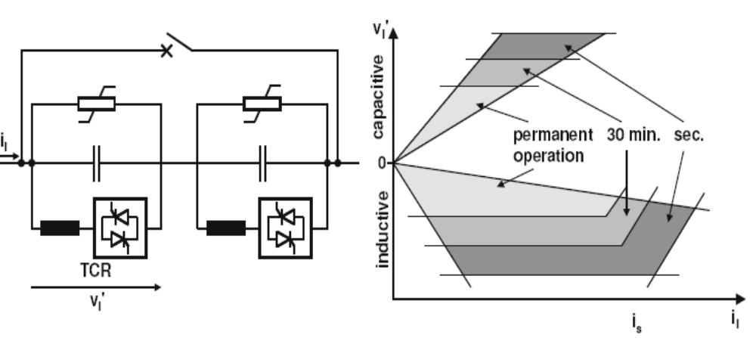
Fig 3.12: circuit & characteristics for TCSC
3.3.2 Advantages:
Continuous control of desired compensation level
- Direct smooth control of power flow within the network
- Improved capacitor bank protection
- Local mitigation of sub synchronous resonance (SSR). This permits higher levels of compensation in networks where interactions with turbine-generator torsional vibrations or with other control or measuring systems are of concern.
- Damping of electromechanical (0.5-2 Hz) power oscillations which often arise between areas in a large interconnected power network. These oscillations are due to the dynamics of inter area power transfer and often exhibit poor damping when the aggregate power transfer over a corridor is high relative to the transmission strength.
3.4 Shunt and Series devices:
3.4.1 Dynamic power flow controller:
A new device in the area of power flow control is the Dynamic Power Flow Controller (DFC). The DFC is a hybrid device between a Phase Shifting Transformer (PST) and switched series compensation.
A functional single line diagram of the Dynamic Flow Controller is shown in Figure 1.19. The Dynamic Flow Controller PST)
• Series-connected Thyristor Switched Capacitors and Reactors (TSC / TSR)
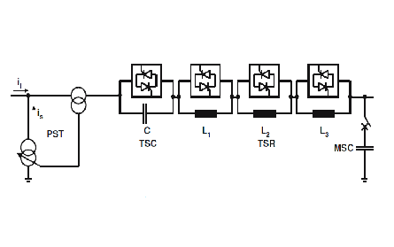
Fig 3.13: circuit for DFC
Based on the system requirements, a DFC might consist of a number of series TSC or TSR. The mechanically switched shunt capacitor (MSC) will provide voltage support in case of overload and other conditions. Normally the reactance of reactors and the capacitors are selected based on a binary basis to result in a desired stepped reactance variation. If a higher power flow resolution is needed, a reactance equivalent to the half of the smallest one can be added.
The switching of series reactors occurs at zero current to avoid any harmonics. However, in general, the principle of phase-angle control used in TCSC can be applied for a continuous control as well. The operation of a DFC is based on the following rules:
• TSC / TSR are switched when a fast response is required.
• The relieve of overload and work in stressed situations is handled by the TSC / TSR.
• The switching of the PST tap-changer should be minimized particularly for the currents higher than normal loading.
• The total reactive power consumption of the device can be optimized by the operation of the MSC, tap changer and the switched capacities and reactors.
In order to visualize the steady state operating range of the DFC, we assume an inductance in parallel representing parallel transmission paths. The overall control objective in steady state would be to control the distribution of power flow between the branch with the DFC and the parallel path. This control is accomplished by control of the injected series voltage.
The PST (assuming a quadrature booster) will inject a voltage in quadrature with the node voltage. The controllable reactance will inject a voltage in quadrature with the throughput current. Assuming that the power flow has a load factor close to one, the two parts of the series voltage will be close to collinear. However, in terms of speed of control, influence on reactive power balance and effectiveness at high/low loading the two parts of the series voltage has quite different characteristics. The steady state control range for loadings up to rated current is illustrated in Figure 1.20, where the x-axis corresponds to the through put current and the y-axis corresponds to the injected series voltage.
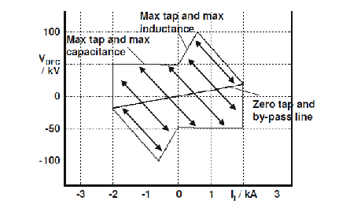
Fig 3.14: Operational diagram of a DFC
Operation in the first and third quadrants corresponds to reduction of power through the DFC, whereas operation in the second and fourth quadrants corresponds to increasing the power flow through the DFC. The slope of the line passing through the origin (at which the tap is at zero and TSC / TSR are bypassed) depends on the short circuit reactance of the PST.
Starting at rated current (2 kA) the short circuit reactance by itself provides an injected voltage (approximately 20 kV in this case). If more inductance is switched in and/or the tap is increased, the series voltage increases and the current through the DFC decreases (and the flow on parallel branches increases). The operating point moves along lines parallel to the arrows in the figure. The slope of these arrows depends on the size of the parallel reactance. The maximum series voltage in the first quadrant is obtained when all inductive steps are switched in and the tap is at its maximum.
Now, assuming maximum tap and inductance, if the throughput current decreases (due e.g. to changing loading of the system) the series voltage will decrease. At zero current, it will not matter whether the TSC / TSR steps are in or out, they will not contribute to the series voltage. Consequently, the series voltage at zero current corresponds to rated PST series voltage. Next, moving into the second quadrant, the operating range will be limited by the line corresponding to maximum tap and the capacitive step being switched in (and the inductive steps by-passed). In this case, the capacitive step is approximately as large as the short circuit reactance of the PST, giving an almost constant maximum voltage in the second quadrant.
3.4.2 Unified power flow controller:
The UPFC is a combination of a static compensator and static series compensation. It acts as a shunt compensating and a phase shifting device simultaneously.
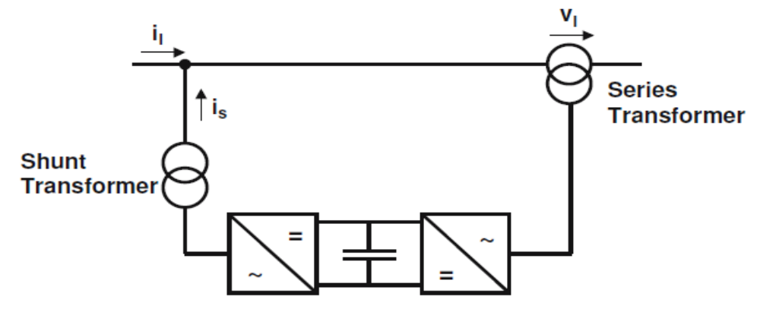
Fig 3.15: circuit for UPFC
The UPFC consists of a shunt and a series transformer, which are connected via two voltage source converters with a common DC-capacitor. The DC-circuit allows the active power exchange between shunt and series transformer to control the phase shift of the series voltage. This setup, as shown in Figure 3.15, provides the full controllability for voltage and power flow. The series converter needs to be protected with a Thyristor bridge. Due to the high efforts for the Voltage Source Converters and the protection, an UPFC is getting quite expensive, which limits the practical applications where the voltage and power flow control is required simultaneously.

3.4.3Operating principle of UPFC:
The basic components of the UPFC are two voltage source inverters (VSIs) sharing a common dc storage capacitor, and connected to the power system through coupling transformers. One VSI is connected to in shunt to the transmission system via a shunt transformer, while the other one is connected in series through a series transformer.
A basic UPFC functional scheme is shown in fig3.16
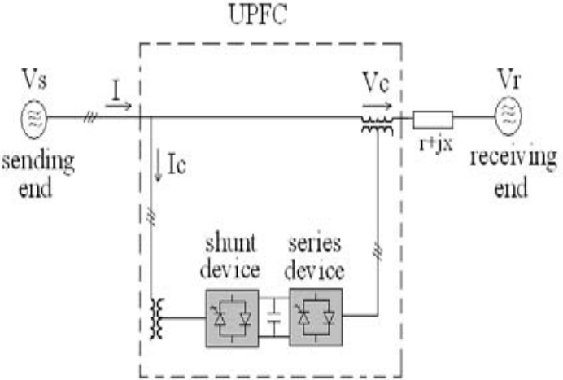
Fig 3.16: principle diagram for UPFC
The series inverter is controlled to inject a symmetrical three phase voltage system (VSC), of controllable magnitude and phase angle in series with the line to control active and reactive power flows on the transmission line. So, this inverter will exchange active and reactive power with the line. The reactive power is electronically provided by the series inverter, and the active power is transmitted to the dc terminals. The shunt inverter is operated in such a way as to demand this dc terminal power (positive or negative) from the line keeping the voltage across the storage capacitor Vdc constant. So, the net real power absorbed from the line by the UPFC is equal only to the losses of the inverters and their transformers. The remaining capacity of the shunt inverter can be used to exchange reactive power with the line so to provide a voltage regulation at the connection point.
The two VSI’s can work independently of each other by separating the dc side. So in that case, the shunt inverter is operating as a STATCOM that generates or absorbs reactive power to regulate the voltage magnitude at the connection point. Instead, the series inverter is operating as SSSC that generates or absorbs reactive power to regulate the current flow, and hence the power low on the transmission line.
The UPFC has many possible operating modes. In particular, the shunt inverter is operating in such a way to inject a controllable current, is into the transmission line. The shunt inverter can be controlled in two different modes.
3.4.4 VAR Control Mode:
The reference input is an inductive or capacitive VAR request. The shunt inverter control translates the var reference into a corresponding shunt current request and adjusts gating of the inverter to establish the desired current. For this mode of control a feedback signal representing the dc bus voltage, Vdc, is also required.
Automatic Voltage Control Mode: The shunt inverter reactive current is automatically regulated to maintain the transmission line voltage at the point of connection to a reference value. For this mode of control, voltage feedback signals are obtained from the sending end bus feeding the shunt coupling transformer.
The series inverter controls the magnitude and angle of the voltage injected in series with the line to influence the power flow on the line. The actual value of the injected voltage can be obtained in several ways.
Direct Voltage Injection Mode: The reference inputs are directly the magnitude and phase angle of the series voltage. Phase Angle Shifter Emulation mode: The reference input is phase displacement between the sending end voltage and the receiving end voltage. Line Impedance Emulation mode. The reference input is an impedance value to insert in series with the line impedance. Automatic Power Flow Control Mode: The reference inputs are values of P and Q to maintain on the transmission line despite system changes.
3.4.5 Real and reactive power control of UPFC:
The basic control for the UPFC is such that the series converter of the UPFC controls the transmission line real/reactive power flow and the shunt converter of the UPFC controls the UPFC bus voltage/shunt reactive power and the DC link capacitor voltage. In steady state, the real power demand of the series converter is supplied by the shunt converter of the UPFC. To avoid instability/loss of DC link capacitor voltage during transient conditions, a n w real power coordination controller has been designed. The need for reactive power coordination controller for UPFC arises from the fact that excessive bus voltage (the bus to which the shunt converter is connected) excursions occur during reactive power transfers. A new reactive power coordination controller has been designed to limit excessive voltage excursions during reactive power transfers. Simulation results have been presented to show the improvement in the performance of the UPFC control with the proposed real power and reactive power coordination controller
IV. INTRODUCTION TO POWER ELECTRONICS
Power Electronics is a field which combines Power (electric power), Electronics and Control systems. Power engineering deals with the static and rotating power equipment for the generation, transmission and distribution of electric power. Electronics deals with the study of solid state semiconductor power devices and circuits for Power conversion to meet the desired control objectives (to control the output voltage and output power).
Power electronics may be defined as the subject of applications of solid state power semiconductor devices (Thyristors) for the control and conversion of electric power.
Power electronics deals with the study and design of Thyristorised power controllers for variety of application like Heat control, Light/Illumination control, Motor control – AC/DC motor drives used in industries, High voltage power supplies, Vehicle propulsion systems, High voltage direct current (HVDC) transmission.
4.1Power electronic applications:
- Commercial applications
Heating systems, Ventilating, Air conditioners, Central refrigeration, Lighting , Computers and office equipments, Uninterruptible Power supplies (UPS), Elevators, and Emergency lamps.
- Domestic applications:
Cooking Equipments, Lighting, Heating, Air Conditioners, Refrigerators & Freezers, Personal Computers, Entertainment Equipments, UPS.
- Industrial applications:
Pumps, compressors, blowers and fans. Machine tools, arc furnaces, induction furnaces, lighting control circuits, industrial lasers, induction heating, welding equipments.
- Aerospace applications:
Space shuttle power supply systems, satellite power systems, aircraft power systems.
- Telecommunications:
Battery chargers, Power supplies (DC and UPS), Mobile cell phone battery chargers.
- Transportation:
Traction control of electric vehicles, Battery chargers for electric vehicles, electric locomotives, street cars, trolley buses, automobile electronics including engine controls.
- Utility systems:
High voltage DC transmission (HVDC), static VAR compensation (SVC), Alternative energy sources (wind, photovoltaic), fuel cells, energy storage systems, induced draft fans and boiler feed water pumps.
4.2 Differences between electronics and Power Electronics:
This question can be answered in number of ways. The simplest way to say all the electronics devices which deals with power are covered in Power Electronics. There are devices which you do use in general purpose electronics like: Diode, BJT, MFETs etc. You will find these devices in electronics & power electronics both. The devices used in Power electronics may differ in term of construction & behavior from those used in electronics. There are type of devices which you will find only IN PE, ex: IGBT.
- The only difference is that power devices (e.g. MOSFETs) are made to handle much larger power requirements.
- Ordinary devices are low current and low voltage devices.
- Power devices are high current and/or high voltage devices.
4.3 Power converters:
A power converter is an electrical or electro-mechanical device for converting electrical energy. It may be converting AC to or from DC, or the voltage or frequency, or some combination of these.
Amongst the many devices that are used for this purpose are;
- Rectifier
- Inverter
- DC - DC converter
- AC - AC converter
- AC - DC converter (rectifier):
A rectifier is an electrical device that converts alternating current (AC), which periodically reverses direction, to direct current (DC), which is in only one direction, a process known as rectification.
Rectifiers have many uses including as components of power supplies and as detectors of radio signals. Rectifiers may be made of solid state diodes, vacuum tube diodes, mercury arc valves, and other components.
- DC - AC converter (inverter):
An inverter is an electrical device that converts direct current (DC) to alternating current (AC); the converted AC can be at any required voltage and frequency with the use of appropriate transformers, switching, and control circuits.
Solid-state inverters have no moving parts and are used in a wide range of applications, from small switching power supplies in computers, to large electric utility high-voltage direct current applications that transport bulk power. Inverters are commonly used to supply AC power from DC sources such as solar panels or batteries.
- DC - DC converter (choppers):
A dc chopper is a dc-to-dc voltage converter. It is a static switching electrical appliance that in one Electrical conversion, changes an input fixed dc voltage to an adjustable dc output voltage without Inductive or capacitive intermediate energy storage. The name chopper is connected with the fact that the output voltage is a ‘chopped up’ quasi-rectangular version of the input dc voltage.
4 .AC - AC converter:
An AC/AC converter converts an AC waveform such as the mains supply, to another AC waveform, where the output voltage and frequency can be set arbitrarily.
AC/AC converters can be categorized into
- Cycloconverters
- Matrix Converters

4.4 Power Electronic Switches:
In electronics, a switch is an electrical component that can break an electrical circuit, interrupting the current or diverting it from one conductor to another.
A power electronic switch integrates a combination of power electronic components or power semiconductors and a driver for the actively switchable power semiconductors. The internal functional correlations and interactions of this integrated system determine several
4.4.1 Diode:
In electronics, a diode is a type of two-terminal electronic component with a nonlinear current–voltage characteristic. A semiconductor diode, the most common type today, is a crystalline piece of semiconductor material connected to two electrical terminals. A vacuum tube diode (now rarely used except in some high-power technologies) is a vacuum tube with two electrodes: a plate and a cathode.
The most common function of a diode is to allow an electric current to pass in one direction (called the diode's forward direction), while blocking current in the opposite direction (the reverse direction). Thus, the diode can be thought of as an electronic version of a check valve. This unidirectional behavior is called rectification, and is used to convert alternating current to direct current, and to extract modulation from radio signals in radio receivers.
However, diodes can have more complicated behavior than this simple on–off action. Semiconductor diodes do not begin conducting electricity until a certain threshold voltage is present in the forward direction (a state in which the diode is said to be forward biased). The voltage drop across a forward biased diode varies only a little with the current, and is a function of temperature; this effect can be used as a temperature sensor or voltage reference.
Semiconductor diodes have nonlinear electrical characteristics, which can be tailored by varying the construction of their P–N junction. These are exploited in special purpose diodes that perform many different functions.
Diodes were the first semiconductor electronic devices. The discovery of crystals' rectifying abilities was made by German physicist Ferdinand Braun in 1874. The first semiconductor diodes, called cat's whisker diodes, developed around 1906, were made of mineral crystals such as galena. Today most diodes are made of silicon, but other semiconductors such as germanium are sometimes used.
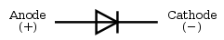
A modern semiconductor diode is made of a crystal of semiconductor like silicon that has impurities added to it to create a region on one side that contains negative charge carriers (electrons), called n-type semiconductor, and a region on the other side that contains positive charge carriers (holes), called p-type semiconductor. The diode's terminals are attached to each of these regions. The boundary within the crystal between these two regions, called a PN junction, is where the action of the diode takes place. The crystal conducts a current of electrons in a direction from the N-type side (called the cathode) to the P-type side (called the anode), but not in the opposite direction. However, conventional current flows from anode to cathode in the direction of the arrow (opposite to the electron flow, since electrons have negative charge).
Another type of semiconductor diode, the Scotty diode, is formed from the contact between a metal and a semiconductor rather than by a p–n junction.
4.4.2 Thyristor:
A thyristor is a solid-state semiconductor device with four layers of alternating n and p-type material. They act as bistable switches, conducting when their gate receives a current pulse, and continue to conduct while they are forward biased (that is, while the voltage across the device is not reversed).
Some sources define silicon controlled rectifiers and thyristors as synonymous.
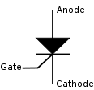
Fig 4.1: Circuit symbol for a thyristor
Function:
The thyristor is a four-layer, three terminal semiconducting device, with each layer consisting of alternately N-type or P-type material, for example P-N-P-N. The main terminals, labeled anode and cathode, are across the full four layers, and the control terminal, called the gate, is attached to p-type material near to the cathode. (A variant called an SCS—Silicon Controlled Switch—brings all four layers out to terminals.) The operation of a thyristor can be understood in terms of a pair of tightly coupled bipolar junction transistors, arranged to cause the self-latching action:
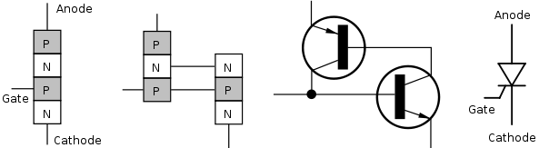
Fig 4.2: Structure on the physical and electronic level, and the thyristor symbol.
Thyristors have three states:
- Reverse blocking mode — Voltage is applied in the direction that would be blocked by a diode
- Forward blocking mode — Voltage is applied in the direction that would cause a diode to conduct, but the thyristor has not yet been triggered into conduction
- Forward conducting mode — The thyristor has been triggered into conduction and will remain conducting until the forward current drops below a threshold value known as the "holding current"

4.4.3 Insulated gate bipolar transistor (IGBT):
The insulated-gate bipolar transistor or IGBT is a three-terminal power semiconductor device, noted for high efficiency and fast switching. It switches electric power in many modern appliances: electric cars, variable speed refrigerators, air-conditioners, and even stereo systems with digital amplifiers. Since it is designed to rapidly turn on and off, amplifiers that use it often synthesize complex waveforms with pulse width modulation and low-pass filters.
The IGBT combines the simple gate-drive characteristics of the MOSFETs with the high-current and low–saturation-voltage capability of bipolar transistors by combining an isolated-gate FET for the control input, and a bipolar power transistor as a switch, in a single device. The IGBT is used in medium- to high-power applications such as switched-mode power supply, traction motor control and induction heating. Large IGBT modules typically consist of many devices in parallel and can have very high current handling capabilities in the order of hundreds of amps with blocking voltages of 6,000 V.
Equivalent circuit:
An examination of reveals that if we move vertically up from collector to emitter. We come across p+, n- , p layer s. Thus, IGBT can be thought of as the combination of MOSFET and p+ n⁻ p layer s. Thus, IGBT can be thought of as the combination of MOSFET and p⁺ n⁻ p transistor Q1 .Here Rd is resistance offered by n – drift region. Approximate equivalent circuit of an IGBT.
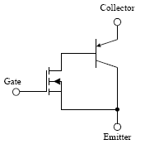
Fig 4.3: Equivalent Circuit For IGBT

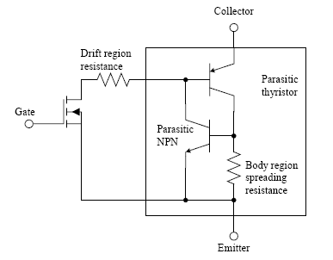
Fig 4.4: Circuit For IGBT
4.4.4 MOSFET:
The metal–oxide–semiconductor field-effect transistor (MOSFET, MOS-FET, or MOS FET) is a transistor used for amplifying or switching electronic signals. The basic principle of this kind of transistor was first proposed by Julius Edgar Lilienfeld in 1925. In MOSFETs, a voltage on the oxide-insulated gate electrode can induce a conducting channel between the two other contacts called source and drain. The channel can be of n-type or p-type (see article on semiconductor devices), and is accordingly called an nMOSFET or a pMOSFET (also commonly nMOS, pMOS). It is by far the most common transistor in both digital and analog circuits, though the bipolar junction transistor was at one time much more common.
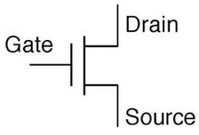
Fig 4.5: Model circuit for MOSFET
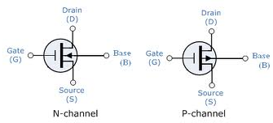
The 'metal' in the name is now often a misnomer because the previously metal gate material is now often a layer of polysilicon (polycrystalline silicon). Aluminium had been the gate material until the mid 1970s, when polysilicon became dominant, due to its capability to form self-aligned gates. Metallic gates are regaining popularity, since it is difficult to increase the speed of operation of transistors without metal gates.
MOSFET operation:
A metal–oxide–semiconductor field-effect transistor (MOSFET) is based on the modulation of charge concentration by a MOS capacitance between a body electrode and a gate electrode located above the body and insulated from all other device regions by a gate dielectric layer which in the case of a MOSFET is an oxide, such as silicon dioxide. If dielectrics other than an oxide such as silicon dioxide (often referred to as oxide) are employed the device may be referred to as a metal–insulator–semiconductor FET (MISFET). Compared to the MOS capacitor, the MOSFET includes two additional terminals (source and drain), each connected to individual highly doped regions that are separated by the body region. These regions can be either p or n type, but they must both be of the same type, and of opposite type to the body region. The source and drain (unlike the body) are highly doped as signified by a '+' sign after the type of doping.
If the MOSFET is an n-channel or n MOSFET, then the source and drain are 'n+' regions and the body is a 'p' region. As described above, with sufficient gate voltage, holes from the body are driven away from the gate, forming an inversion layer or n-channel at the interface between the p region and the oxide. This conducting channel extends between the source and the drain, and current is conducted through it when a voltage is applied between source and drain. Increasing the voltage on the gate leads to a higher electron density in the inversion layer and therefore increases the current flow between the source and drain.
For gate voltages below the threshold value, the channel is lightly populated, and only a very small sub threshold leakage current can flow between the source and the drain.
If the MOSFET is a p-channel or p MOSFET, then the source and drain are 'p+' regions and the body is a 'n' region. When a negative gate-source voltage (positive source-gate) is applied, it creates a p-channel at the surface of the n region, analogous to the n-channel case, but with opposite polarities of charges and voltages.
When a voltage less negative than the threshold value (a negative voltage for p-channel) is applied between gate and source, the channel disappears and only a very small sub threshold current can flow between the source and the drain.
The source is so named because it is the source of the charge carriers (electrons for n-channel, holes for p-channel) that flow through the channel; similarly, the drain is where the charge carriers leave the channel.
The device may comprise a Silicon On Insulator (SOI) device in which a Buried Oxide (BOX) is formed below a thin semiconductor layer. If the channel region between the gate dielectric and a Buried Oxide (BOX) region is very thin, the very thin channel region is referred to as an Ultra Thin Channel (UTC) region with the source and drain regions formed on either side thereof in and/or above the thin semiconductor layer. Alternatively, the device may comprise a Semiconductor On Insulator (SEMOI) device in which semiconductors other than silicon are employed. Many alternative semiconductor materials may be employed.

V. REFERENCE MODELING DIAGRAM
Use of an SVC close to an HVDC transmission system can improve voltage quality and system stability during and after faults and increase transient stability. Here we are considering a DC link between two converters.
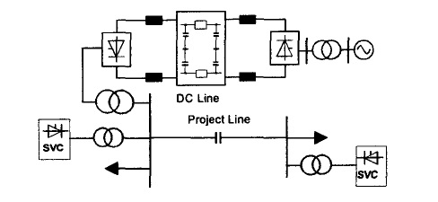
Fig 5.1: Reference model diagram
By considering the reference circuit for without facts devices, the actual circuit is build by using the MATLAB. In this circuit we are considering the shunt controllers, and a three phase two winding transformer in this configuration whenever there is fault in the system ,it is not recognized.

5.1 Reference circuit for without facts devices:
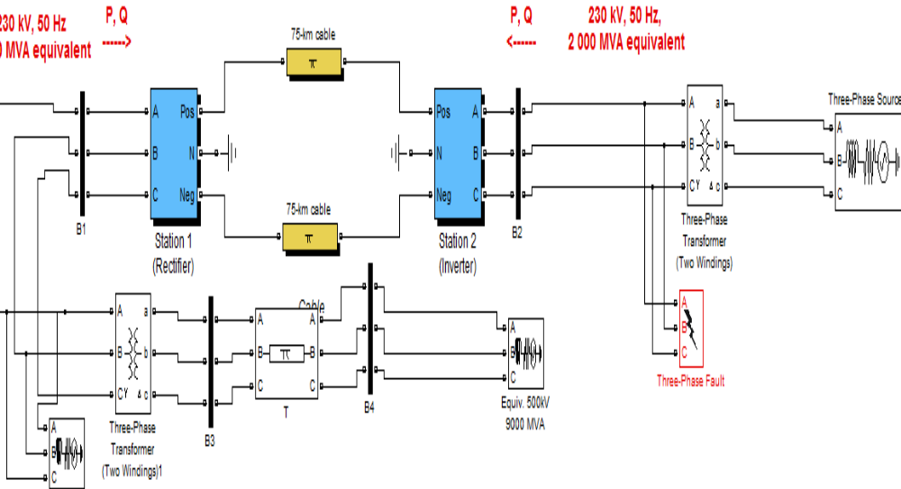
Fig 5.2: Reference circuit for without FACTS devices
Reference circuit for with facts devices is considered. Here the fault location is estimated and rectified. The facts device we are using is svc .svc is the major fact device. The series controllers TSC and TCR are used

5.2 Reference circuit for with facts devices:

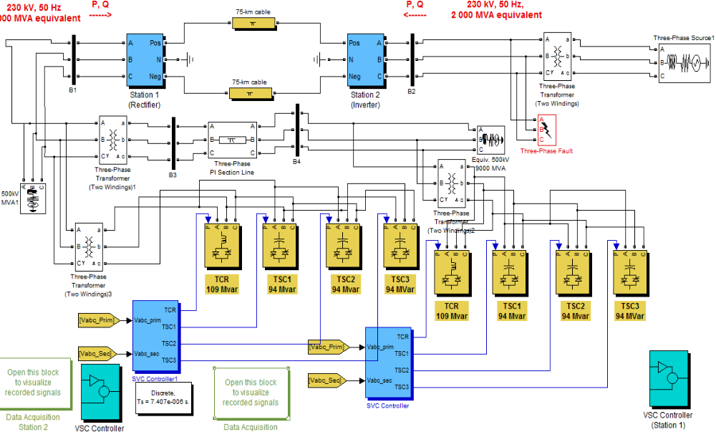
Fig 5.3: Reference circuit for with FACTS devices
In principle the SVC consists of Thyristor Switched Capacitors (TSC) and Thyristor Switched or Controlled Reactors (TSR / TCR). The coordinated control of a combination of these branches varies the reactive power as shown in Figure. The first commercial SVC was installed in 1972 for an electric arc furnace. On transmission level the first SVC was used in 1979. Since then it is widely used and the most accepted FACTS-device.

When large disturbances occur in a power system due to load rejection, there is a possibility for large voltage transients because of oscillatory interaction between system and the SVC capacitor bank or the parallel. The LC circuit of the SVC in the FC compensator. In the TSC–TCR scheme, due to the flexibility of rapid switching of capacitor banks without appreciable disturbance to the power system, oscillations can be avoided, and hence the transients in the system can also be avoided. The capital cost of this SVC is higher than that of the earlier one due to the increased number of capacitor switches and increased control complexity.
5.3 Co-ordination of FACTS and HVDC:
- The co-ordination of FACTS and HVDC reduces the high cost and gives better regulation.
- In the case of cascading events, for the operation of the transmission systems, it gives better performance.
- Whenever the presence of weak point in the energy demand, the co-ordination of FACTS and HVDC solutions are used.
- Under voltage and under frequency, load trip is rectified by using facts and HVDC.
- Active power damping oscillations with FACTS and HVDC.

VI. MATLAB CIRCUIT AND SIMULATIONS.
6.1 Introduction:
A rapidly operating static var compensator (SVC) can continuously provide the reactive power required to control dynamic voltage oscillations under various system conditions and thereby improve the power system transmission and distribution stability.
6.2 Block diagram of without FACTS devices:
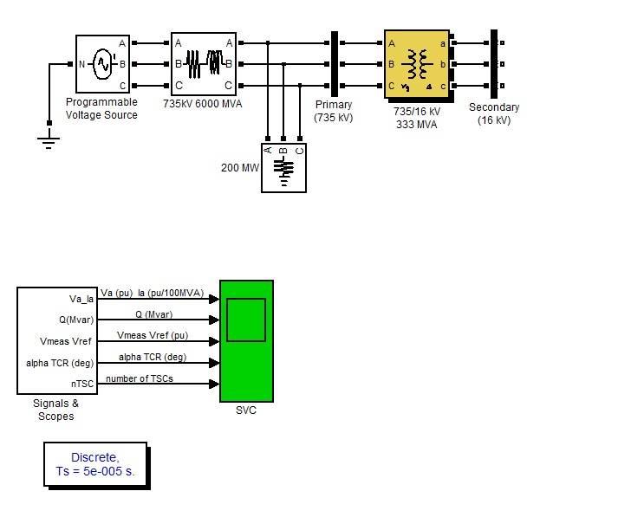 Fig 6.1: MATLAB circuit for without FACTS devices
6.3 Simulation results for without FACTS devices:
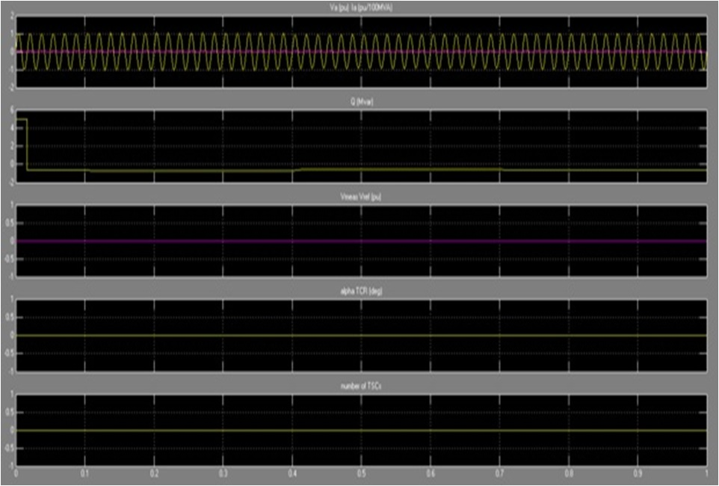

Fig 6.2: Simulation results for without FACTS devices

6.4 MATLAB circuit for with FACTS devices:
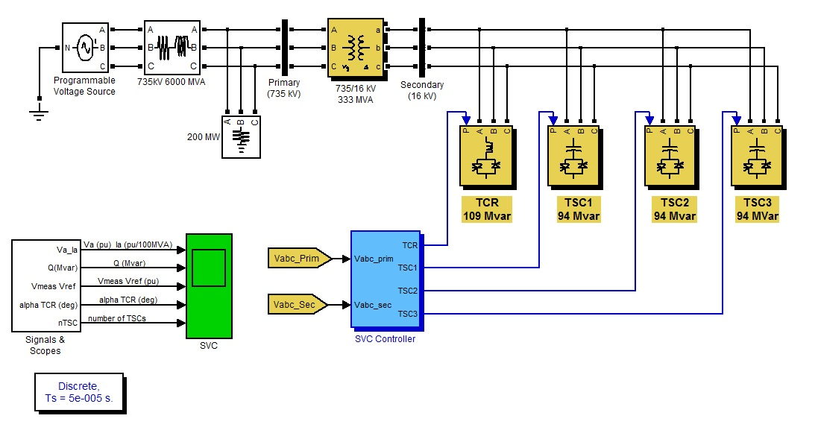
Fig 6.3: MATLAB circuit for with FACTS devices
6.5 Simulation results for with FACTS devices:
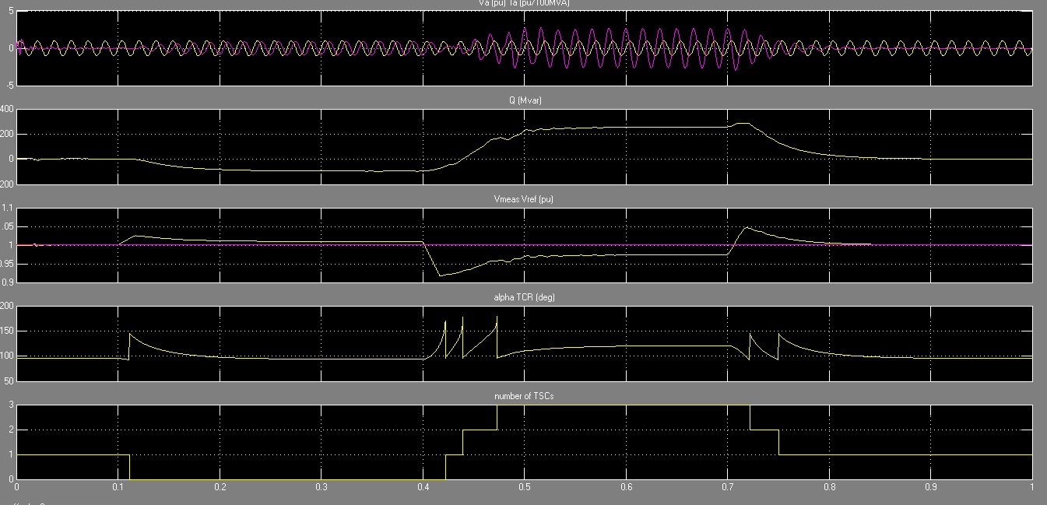
Fig 6.4: Simulation results for FACTS devices

VII. CONCLUSION & FUTURE SCOPE
Operation requirements on AC and DC transmission systems will strongly focus on reliability and quality of electrical energy. The HVDC and FACTS techniques have been as an advanced means for improving overall power system performance. HVDC and FACTS devices can provide the necessary operation characteristics, and thus efficiently improve the system dynamic performance, especially under weak and very weak system conditions. In this paper, coordinated operations and achievable benefits of the HVDC and THYRISTOR-based FACTS devices have been demonstrated. These schemes are established technology and the required controls can be easily and quickly developed.
Under weak and very weak power system conditions, the HVDC and FACTS devices provides better dynamic performance.
The coordination of thyristor based FACTS devices and HVDC provides achievable benefits in a economical manner.
In the future 10 years the demand of electricity increases in sustainable manner, in order to achieve it we are using the FACTS and HVDC devices.
REFERENCE
[1] J. Arrillaga, D. A. Bradley, P. S. Bodge, Power System Harmonics, Wiley, 1985.
[2] D. Daniel Sabin and Ashok Sundaram, “Quality Enhances”, IEEE Spectrum, No. 2, PP. 34-38, 1996.
[3] A.M. Sharaf, Hong Huang, Liuchen Chang," Power quality and nonlinear load voltage stabilization using error-driven switched passive power filter", Proc of the IEEE Inter. Symp. on Industrial Electronics, pp 616-621, 1995.
[4] M. Rastogi, N. Mohan, and A.-A. Edris, “Hybrid-active filtering of harmonic currents in power systems,” IEEE Trans. Power Delivery, vol. 10, no. 4, pp. 1994–2000, Oct. 1995.
[5] H. Fujita and H. Akagi, “Apractical approach to harmonic compensation in power system-series connection of passive, active filters,” IEEE Trans. Ind. Applicat., vol. 27, no. 6, pp. 1020–1025, Nov./Dec. 1991.
[6] A. M. Sharaf, Caixia Guo and Hong Huang,“Distribution/Utilization system voltage stabilization and power quality enhancement using intelligent smart filter”, UPEC’95, England, UK, 1995.
[7] M. Aredes, K. Heumann, and E. H. Watanabe, “An universal active power line conditioner,” IEEE Trans. Power Delivery, vol. 13, no. 2, pp. 545–557, Apr. 1998.
[8] M. Rastogi, N. Mohan, and A.-A. Edris, “Hybrid-active filtering of harmonic currents in power systems,” IEEE Trans. Power Delivery, vol. 10, no. 4, pp. 1994–2000, Oct. 1995.
[9] H. Fujita and H. Akagi , “A hybrid active filter for damping of harmonic resonance in industrial power system,” IEEE Trans. Power Electron., vol. 15, no. 2, pp. 215–222, Mar. 2000.
[10] A. M. Sharaf, and G. Wang, "Wind Energy System Voltage and Energy Enhancement using Low Cost Dynamic Capacitor Compensation Scheme." Proceedings of the IEEE International Conference on Electrical, Electronic and Computer Engineering. pp. 804-807, 5-7 Sept. 2004.

